**Devizes Car Parks**

Wharf street car park: Wharf St, Devizes SN10 1EA. £6.70/day

Sheep Street Car park: 16 Sheep St, Devizes SN10 1LF. £6.70/day

Unloading and loading is right outside the Corn Exchange front door on ‘The market place’. Once the vehicle is empty, stall holders must move their vehicles to one of the many nearby council car parks. If stall holders require a longer time to unload then there is limited parking for a small fee, in ‘The Market Place’ itself, this being just a short walk of the Corn Exchange.

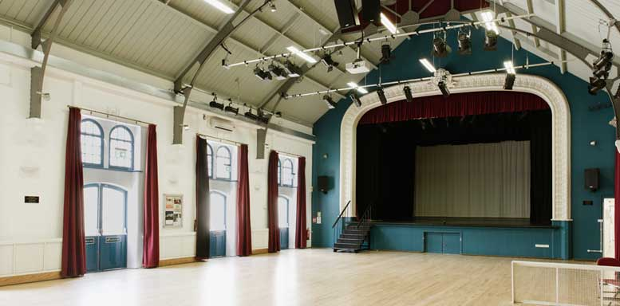





Devizes Corn Exchange

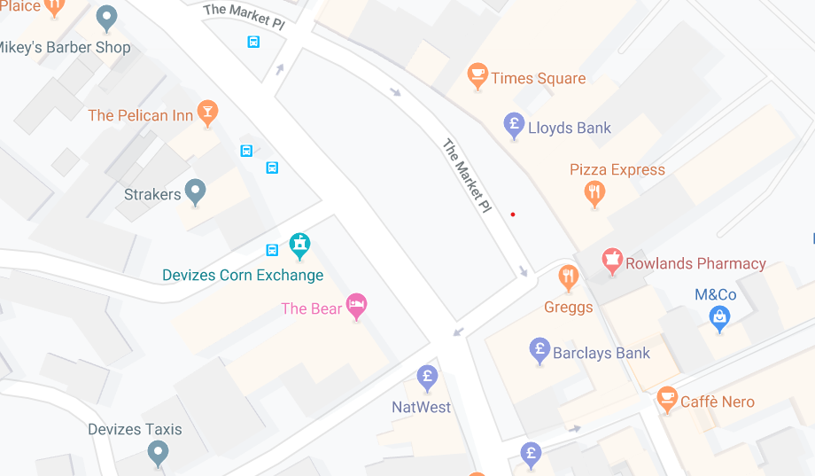

Ceres Hall

Devizes Corn Exchange

The Market Place,

Devizes

SN10 1HS