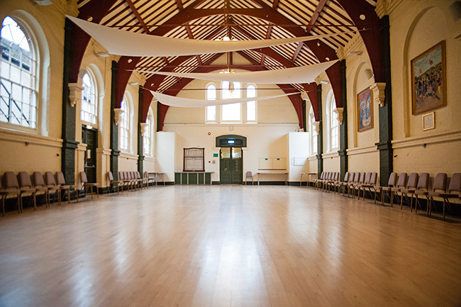

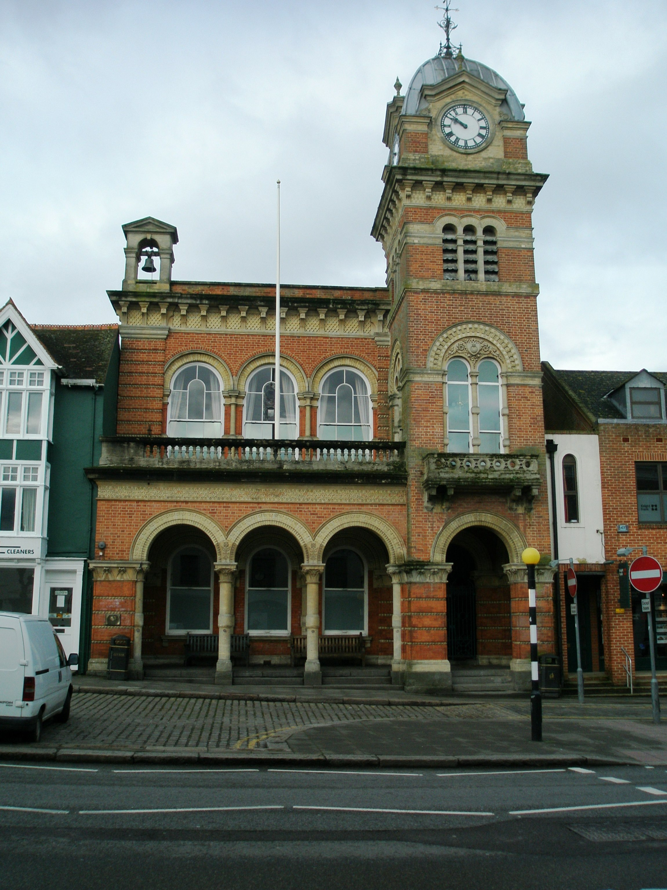

**Parking Charges (July 2018)**

|  |  |
| --- | --- |
| **Monday to Saturday 6am to 6pm** | |
| Up to one hour | £0.80 |
| Up to two hours | £1.30 |
| Up to three hours | £1.70 |
| Up to four hours | £2 |
| Up to ten hours | £4 |

**Unloading:** All unloading is to the rear of Hungerford Corn Exchange. There is to be **NO UNLOADING in the High Street**. Stallholders should turn into Church Street from the High Street. Once in Church Street turn left into the rear service road to the back of Hungerford Corn Exchange/Town Hall. Stallholders need to unload their products then move their vehicles immediately into the Church Road public car park (price shown in box below). There is plenty of room to unload to the rear of Hungerford Corn Exchange so long as stallholders move their cars promptly once unloaded and are respectful and courteous towards each other.

Hungerford Corn Exchange

Church Street Car park

**Hungerford Corn Exchange**

**Town Hall, High Street, Hungerford**

**Berkshire, RG17 0NF**

