Unloading and Loading

Unloading and loading are from the Market Place adjacent to the Town Hall. Please unload quickly and move your vehicle to one of the car parks shown on the map above or one of the other car parks in Wallingford which are even cheaper, though further away.

Please move your car quickly to a public car park to allow others to unload in the limited space

Do not bring your car to be loaded at the end of the day until all of your products are packed up, outside, under the Undercroft and ready to be loaded

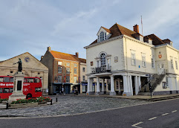

C**ar Park Prices 2023**

Goldsmiths Lane Car park ….. £3.60 for 10 hours

The Cattle Market Car Park …… £3.30 for 10 hours

**Wallingford Town Hall**

Market Place

Wallingford

Oxfordshire

OX10 0EG

Waitrose

Goldsmiths Lane Car Park

The Cattle Market Car Park

The Town Hall

