Romsey Town Hall

[**Address**](https://www.google.com/search?client=firefox-b&q=town+hall+romsey+address&stick=H4sIAAAAAAAAAOPgE-LWT9c3LEnLMDE2r9SSzU620s_JT04syczPgzOsElNSilKLiwE52gRdLgAAAA&sa=X&ved=2ahUKEwjo69eW-LrcAhVLF8AKHZS3BQ8Q6BMwEXoECAsQIQ&biw=1536&bih=700)**: 1** Market Place, Romsey, Hants, SO51 8YZ

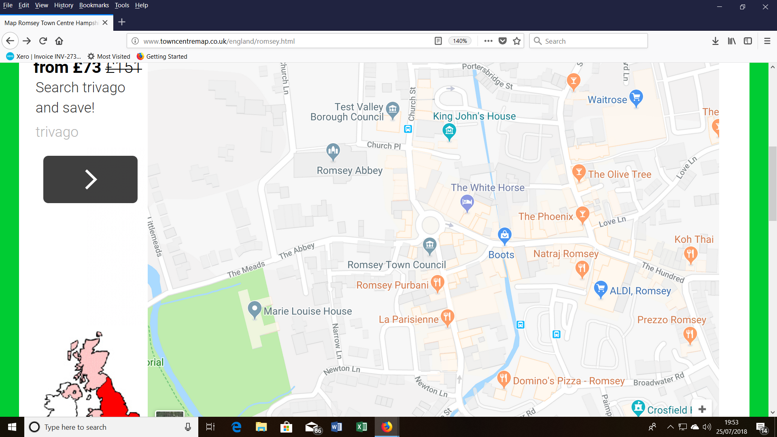

**Unloading can be done right outside the front of the hall.**  Once unloaded, stallholders will need to move their vehicles immediately to one of the many public car parks in Romsey. The price of these (as of July 2018) is given in the adjacent box.

**This is a first floor hall.**  There is NO lift to the floor. Stall holders should note that although Mynt Image staff will be on hand to help unload, they will not be able to help everyone. Stall holders should make sure that they do not pack large heavy boxes but instead utilise a variety of small lighter boxes.

**N.B… Because of our active marketing methods, Mynt Image use many 1st floor and even 2nd floor halls successfully (eg Winchester, Thame, Chippenham, Banbury). Our methods enable us to utilise these venues and create good footfalls rivalling our ground floor venues.**

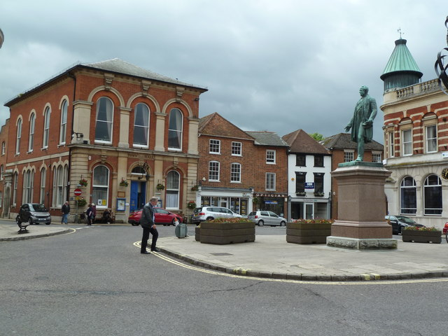

Romsey Town Hall

Loading and unloading can be carried out immediately to the front of the town hall.

**Romsey short to medium stay tariffs / car parks (correct @ July 2018)**

|  |  |  |  |  |  |  |  |
| --- | --- | --- | --- | --- | --- | --- | --- |
| Up to 30 mins | Up to 45 mins | Up to 1 hour | Up to 2 hours | Up to 3 hours | Up to 4 hours | Up to 5 hours | All Day |
| 50p | 70p | £1.00 | £1.60 | £2.00 | £2.70 | £3.40 | £5.90 |
|  | **Car Park Name** | | | | | |  |
|  | Broadwater Road Short Stay | | | | | |  |
|  | Church Road Short Stay | | | | | |  |
|  | Lortemore Place Medium Stay | | | | | |  |
|  | Crosfield Hall Medium Stay (Broadwater Road side max 2 hours, South of car park up to All Day) | | | | | |  |

**Romsey long stay tariffs / car parks**

|  |  |  |  |  |  |  |  |
| --- | --- | --- | --- | --- | --- | --- | --- |
| Up to 30 mins | Up to 45 mins | Up to 1 hour | Up to 2 hours | Up to 3 hours | Up to 4 hours | Up to 5 hours | All Day |
| 50p | 70p | £1.00 | £1.60 | £2.00 | £2.40 | £2.80 | £4.40 |
|  | **Car Park Name** | | | | | |  |
|  | Princes Road Long Stay | | | | | |  |
|  | Alma Road Long Stay | | | | | |  |
| 8 | Romsey Rapids Long Stay Monday to Saturday - free up to 4 hours, daily charge of £2.10 applies when parked for than 4 hours) | | | | | | Motorcycle Disabled Coach Parking* |