**Abingdon Guild Hall parking instructions**

Abingdon-On-Thames Guildhall, Abbey Close, Abingdon, OX14 3JD

The Guildhall

Abbey Close

Abingdon-on-Thames

OX14 3JD

**Unloading is at the rear of the complex next to the cinema entrance.**

**There is NO unloading at the front of the building**

To the rear there are steps and a ramp to unload. Cars need to be unloaded quickly and moved off to one of the local public carparks of which there are several at this end of the town. Cars an not remain parked at the back of the complex fo9r more than a few minutes, thus allowing others to unload here to.

**Civic car park, The Cattle Market car park and Abbey Close park are all …. £5.30**

One of the 2 refurbished rooms we will be using

View of the unloading area at rear. Next to Cinema.

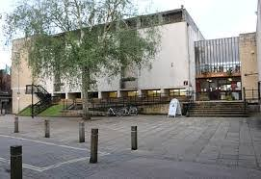

Car parks

Abingdon Guild Hall and cinema

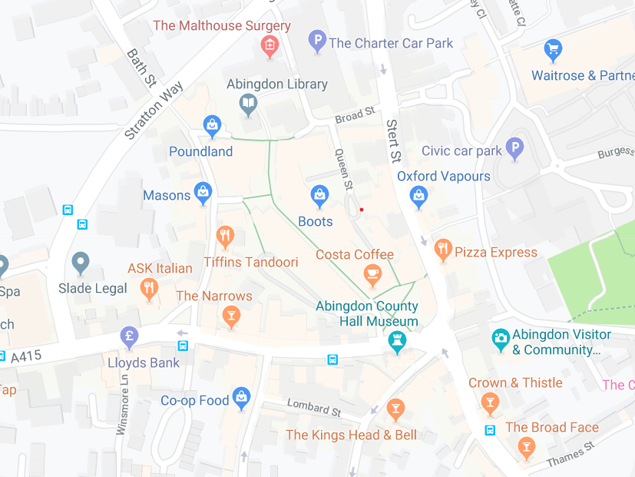

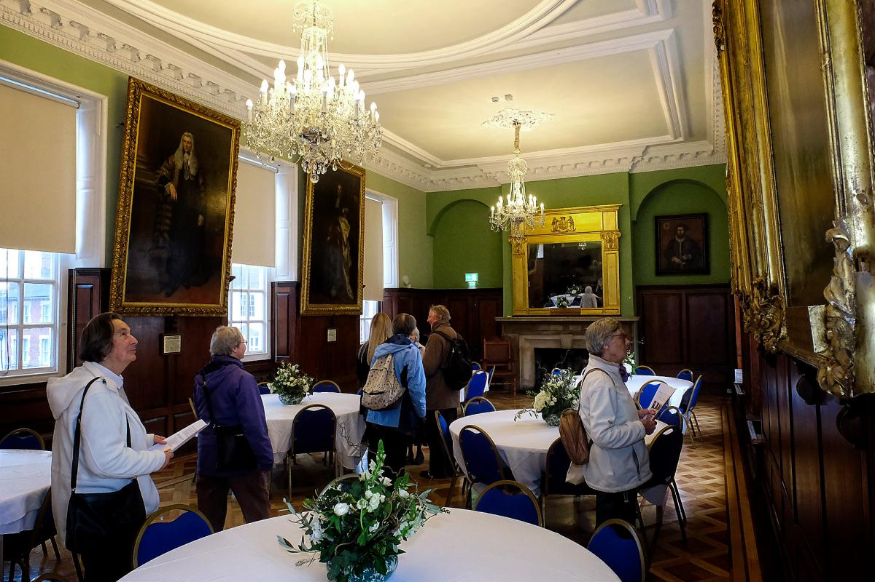

The view from the street

