Lewes Town Hall

[**Address**](https://www.google.com/search?client=firefox-b&q=town+hall+romsey+address&stick=H4sIAAAAAAAAAOPgE-LWT9c3LEnLMDE2r9SSzU620s_JT04syczPgzOsElNSilKLiwE52gRdLgAAAA&sa=X&ved=2ahUKEwjo69eW-LrcAhVLF8AKHZS3BQ8Q6BMwEXoECAsQIQ&biw=1536&bih=700)**: High Street, Lewes, BN7 2QS**

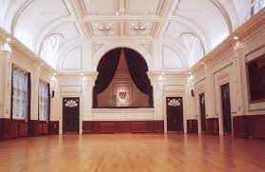

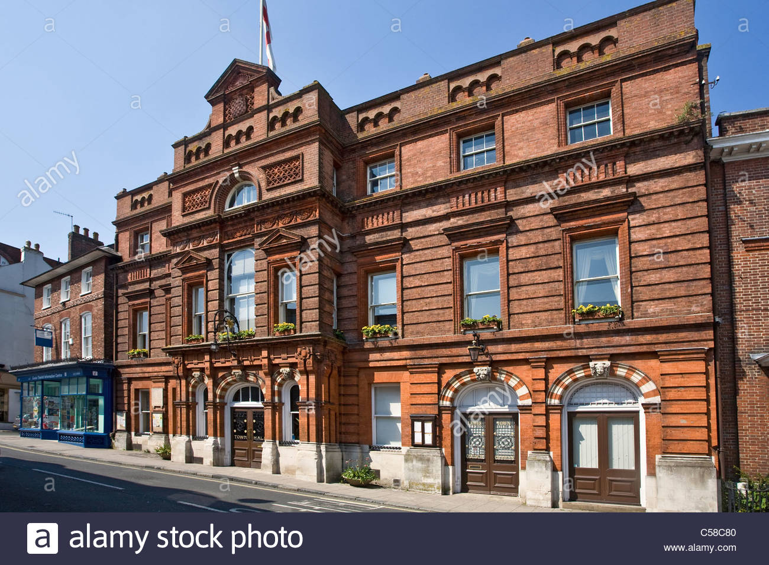

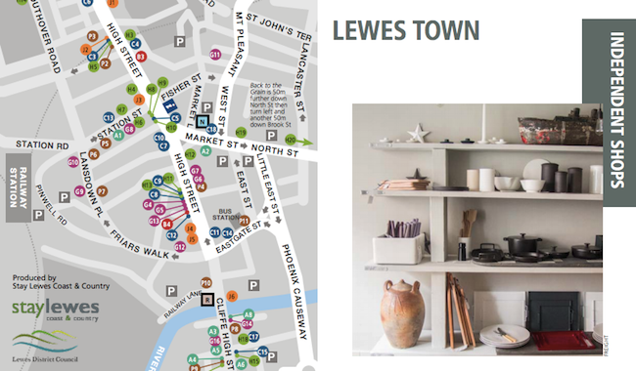

**Unloading and Loading**

There is a yard to the rear of the Town Hall where loading may easily be carried out. Stallholders entering this area will be asked to unload quickly and move on.

Unloading can also occur in Market Lane car park which is just behind the Town Hall. Cars can be left for several hours before moving to a long stay car park.

The rear access to the building is level with no steps making this ideal for those with mobility difficulties.

**N.B….. There is NO unloading or loading in Fisher Street or on the High Street. Stallholders who attempt to park in these areas will be moved on.**

Market Lane

Fisher Street

Town Hall

Close up map of the Town Hall area

|  |  |  |
| --- | --- | --- |
|  |  |  |

Directions:

When coming from the North West, on the High Street:

Turn left just before the Town Hall onto Fisher Street. Fisher Street runs up the side of the Town Hall. Then turn Right into Market lane, which runs behind the Town Hall. Pull into the small parking area behind the Town Hall to unload. After quickly unloading park in one of the many long stay car parks around Lewes.